**Lab Manual- Setup Development Enviornment**

**Prepared for**:

**Date:** 18th Nov 2018

**Prepared by:** Aditi Shrivastava

Document Name: Lab Manual

**Document Number** SysOpsLab311

**Contributor:**

Table of Contents

1 OBJECTIVE 3

2 PRE-REQUISISTE 3

3 Setting up Development Environment 3

**3.1** **Download and Install Git for Windows** 3

**3.2** **Download and Install Visual Studio Code for Windows** 9

**3.3** **Setup Up Azure CLI** 12

**3.4** **Install .NET Core** 14

# OBJECTIVE

For various exercise we need to setup the local development environment where developer will create and update the code for application.

# PRE-REQUISISTE

* Accounts in Azure
* A local Computer with 4 CPU, 16 GB RAM, 200 GB disk space

# Setting up Development Environment



## **Download and Install Git for Windows**

* Browse to the official Git website:

<https://git-scm.com/downloads>

* Click the download link for Windows and allow the download to complete.

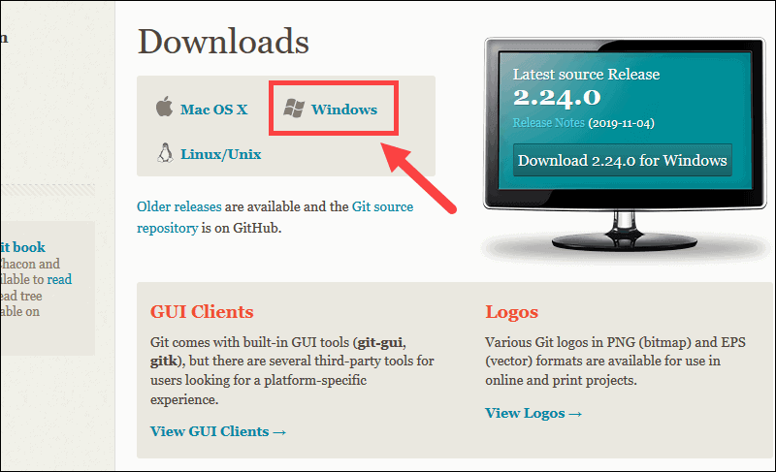

* Browse to the download location (or use the download shortcut in your browser). Double-click the file to extract and launch the installer.

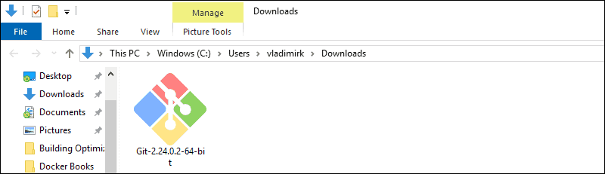

* Allow the app to make changes to your device by clicking **Yes** on the User Account Control dialog that opens

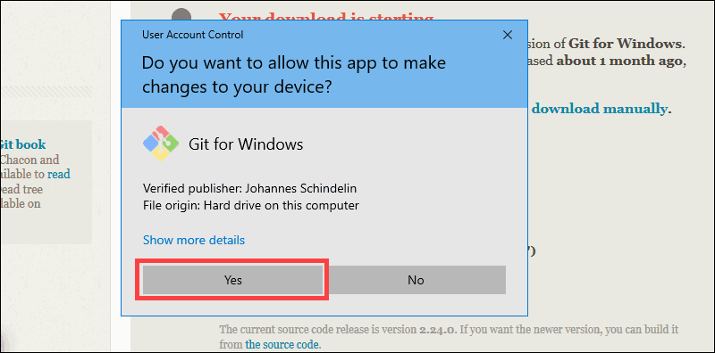

* Review the GNU General Public License, and when you’re ready to install, click Next.

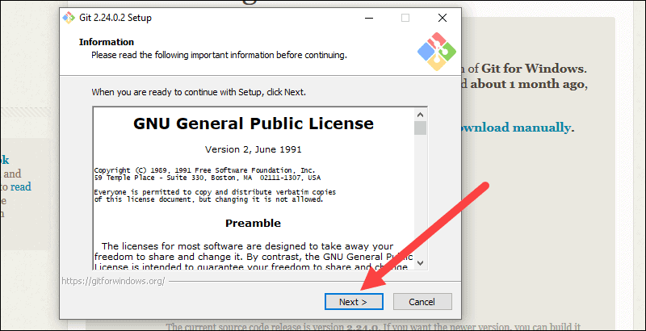

* The installer will ask you for an installation location. Leave the default, unless you have reason to change it, and click Next.

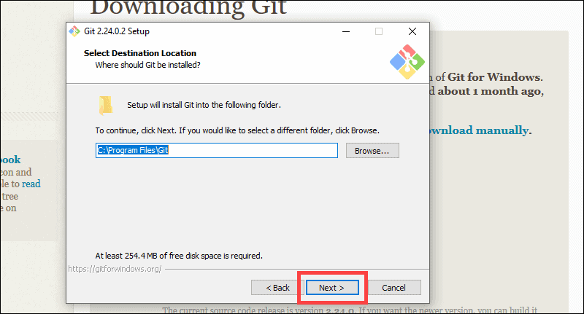

* A component selection screen will appear. Leave the defaults unless you have a specific need to change them and click Next.

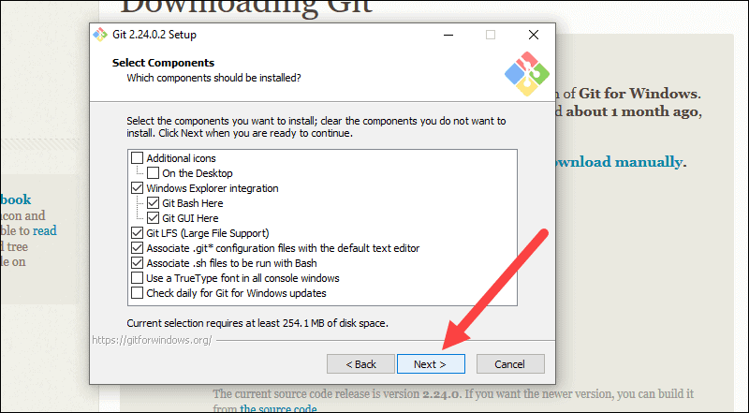

* The installer will offer to create a start menu folder. Simply click **Next.**

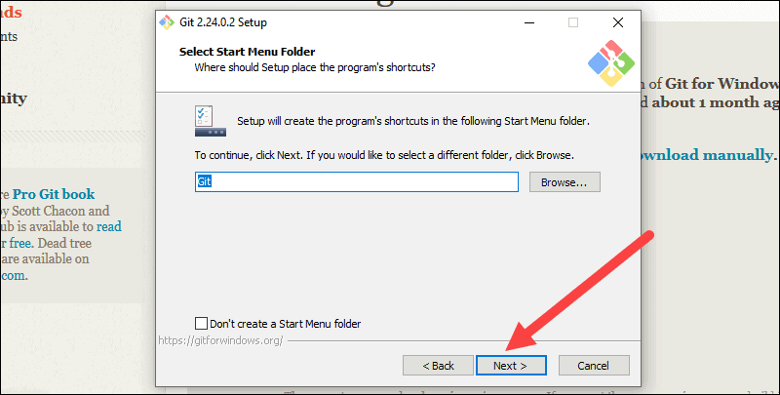

* Select a text editor you’d like to use with Git. Use the drop-down menu to select Notepad++ (or whichever text editor you prefer) and click **Next.**

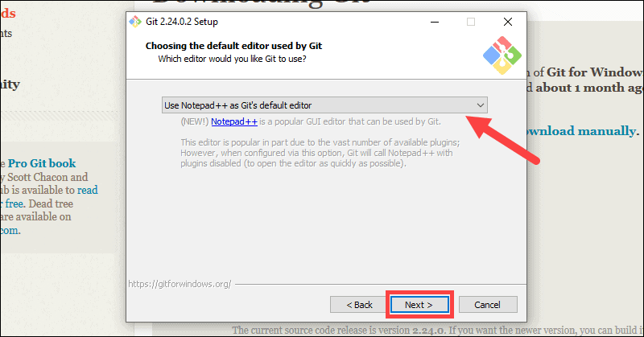

* This installation step allows you to change the **PATH environment**. The PATH is the default set of directories included when you run a command from the command line. Leave this on the middle (recommended) selection and click Next.

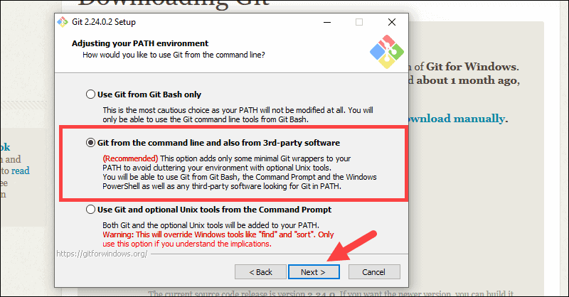

* The next option relates to server certificates. Select Windows Store certificates. Click **Next.**

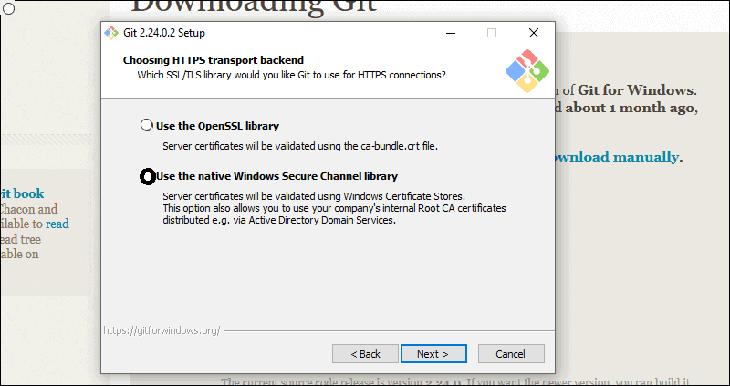

* Leave the default selection. Click **Next.**

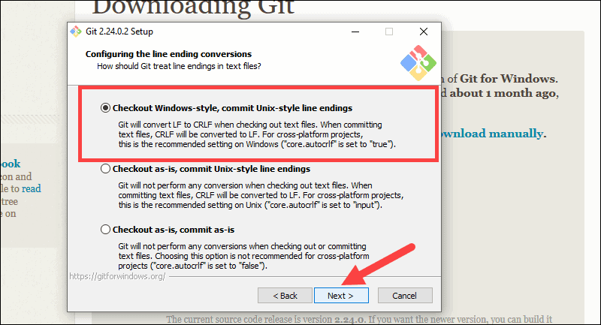

* Choose the Windows Emulator. Click Next.

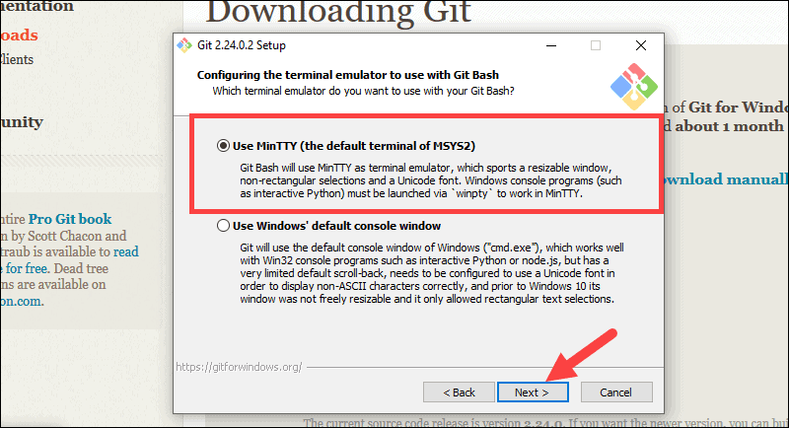

* Click Next

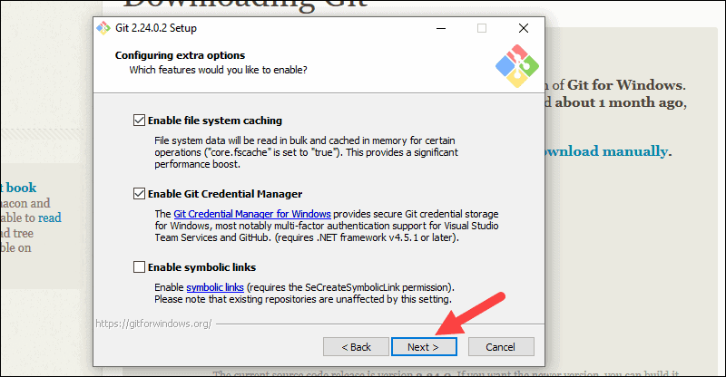

* Leave them experimental features unchecked and click **Install.**

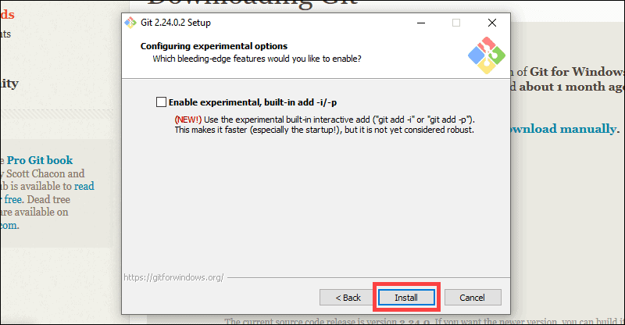

* Once the installation is complete, tick the boxes to view the Release Notes or Launch Git Bash, then click  gbtrbr 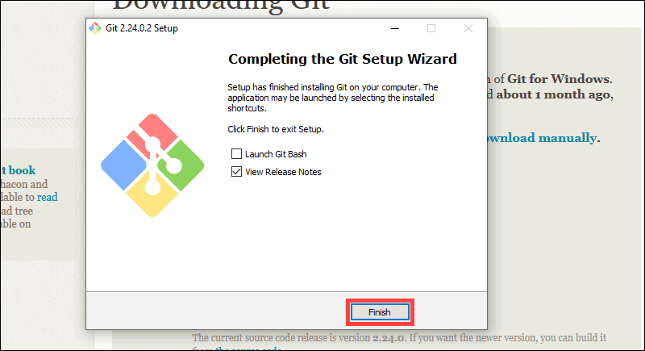

Now Open the command prompt and Configure your local Git installation to use your GitHub credentials by entering the following:

git config ––global user.name “github_username”

git config ––global user.email “email_address”

## **Download and Install Visual Studio Code for Windows**

Visual Studio Code editor is an **open source** editor. So you can use it as **free** for your Ionic project development.

1. To download the Visual Studio Code editor, please go to the below link.

<https://code.visualstudio.com/>

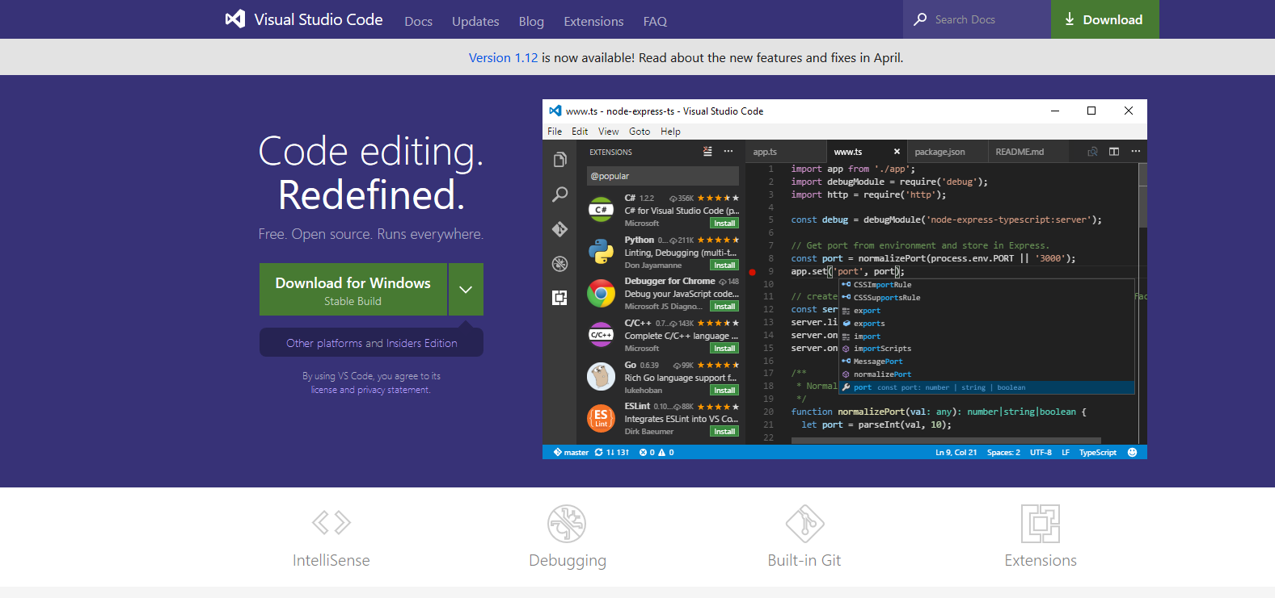

1. Click the download button to download the Visual Studio Code Editor.
2. It is the .exe file. So The installation is as usual windows standard installation. Click next-next.

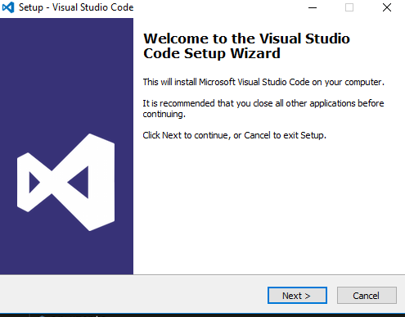

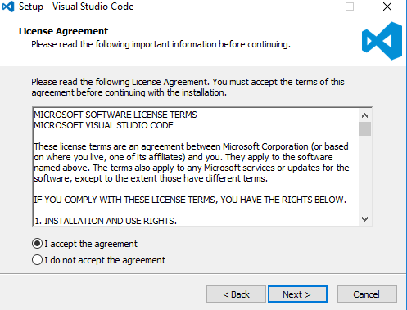

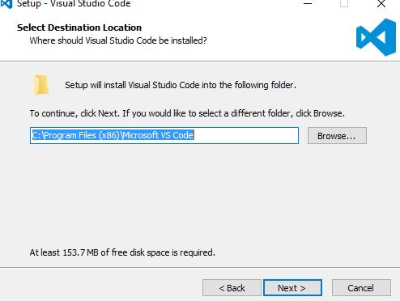

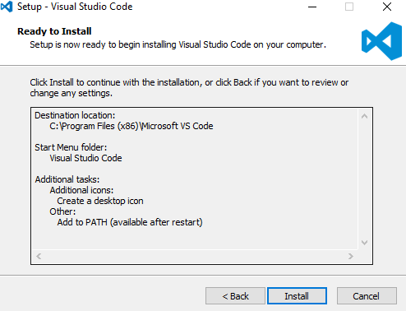

1. Once the installation is done, click the **Launch** option to open the **Visual Studio Code editor**

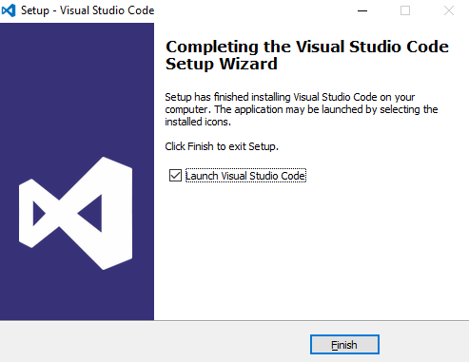

## **Setup Up Azure CLI**

Click on below link to downkload the Azure CLI

<https://aka.ms/installazurecliwindows>

or <https://docs.microsoft.com/en-in/cli/azure/?view=azure-cli-latest>

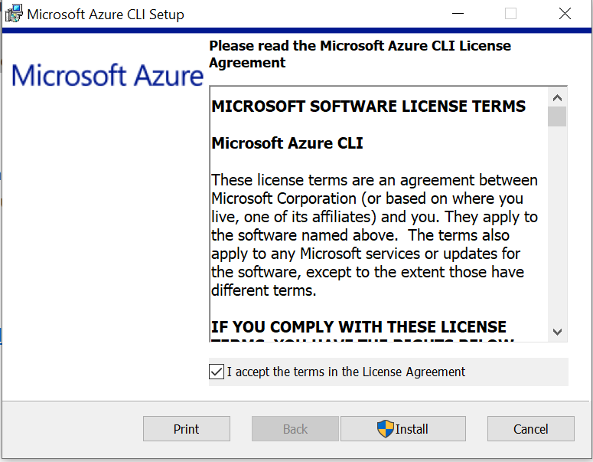

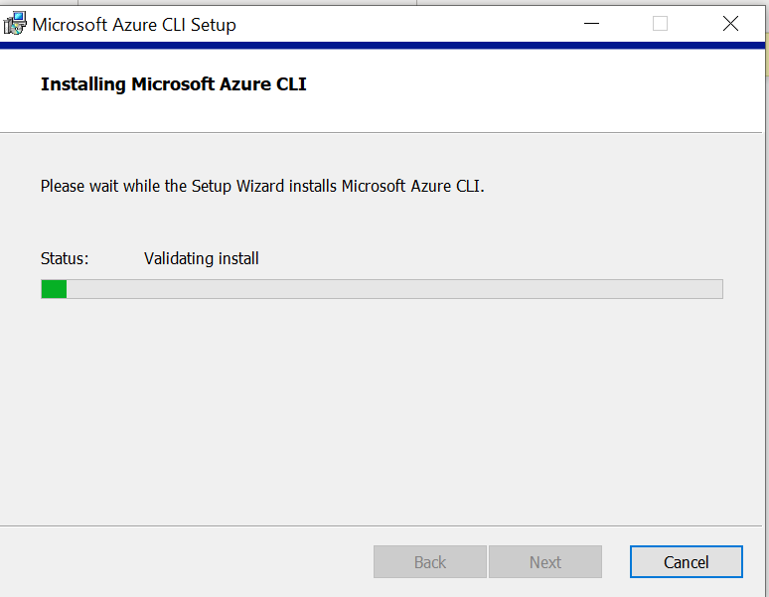

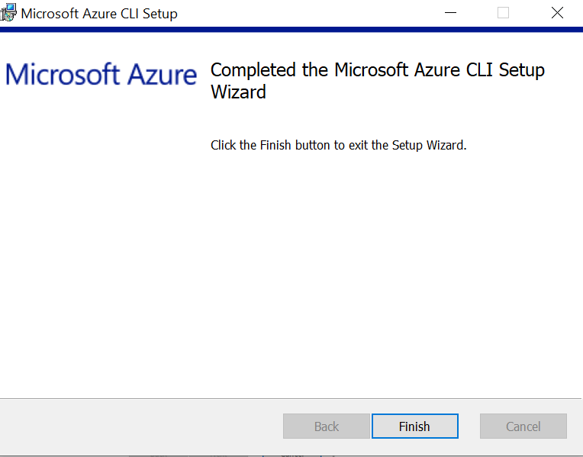

## **Install .NET Core**

* To download the latest version of .NET Core, go to [https://dotnet.microsoft.com/download and select DoteNet 3.1](https://dotnet.microsoft.com/download and%20select%20DoteNet%203.1) SDK

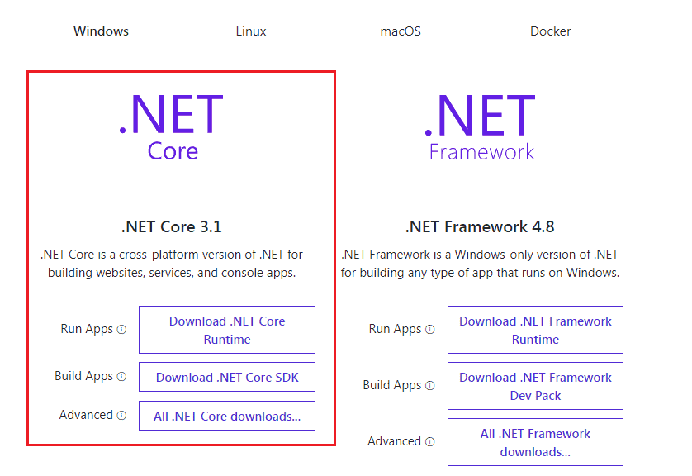

* Installing .Net Core is quite straight forward. Double click on the Downloaded Installer

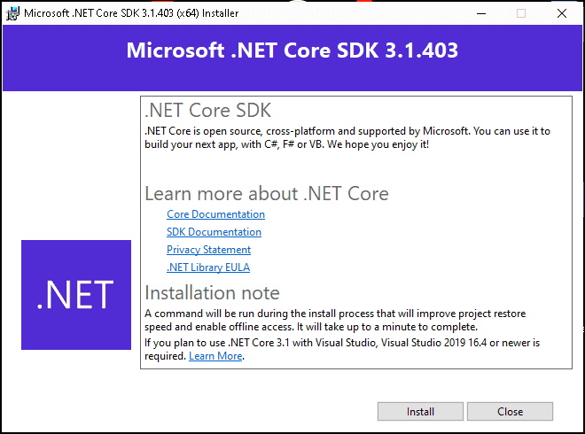

* Click on Install to begin the installation.

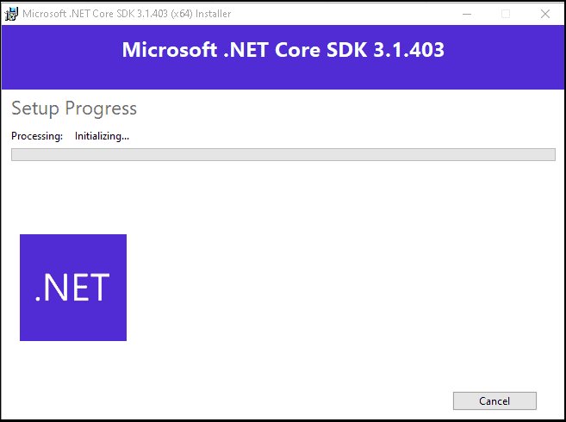

* It will take some time. In the end, you will see the installation successful window. It will give you the details of the component installed.

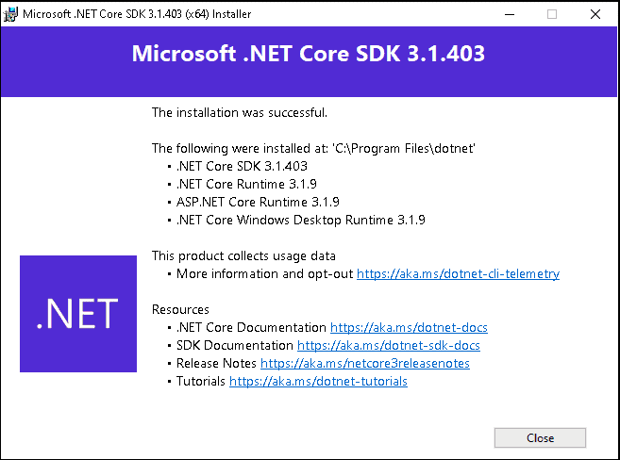

* Path to **dotnet.exe** using where

**Where dotnet**

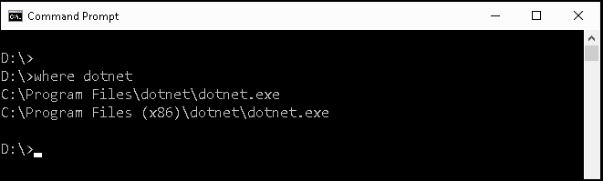

* **dotnet --info** will give you more information is about the .Net core installation as shown below

**dotnet --info**

